Tc001_ecom_cart

Verify product Is added to the cart

open browser > enter url > system displayed home page

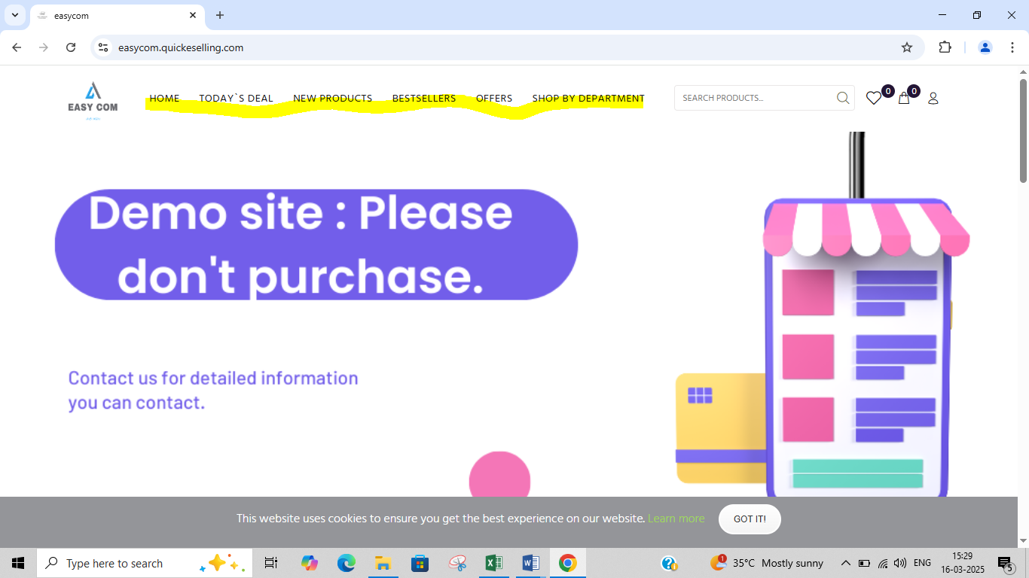

Select Any instock product and click on add to cart > product was added to the cart, confirmation message appeared including product count

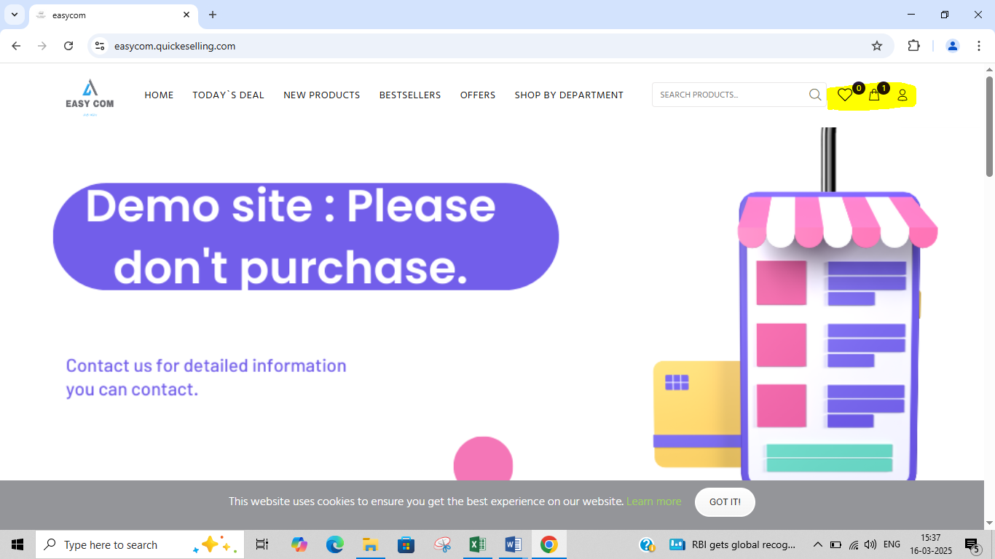

TC002_ecom_cart

Verify cart Reflects correct quantity and price

open browser > enter url > Add Multiple products to the cart > Cart displayed the correct quantity and total price of the products

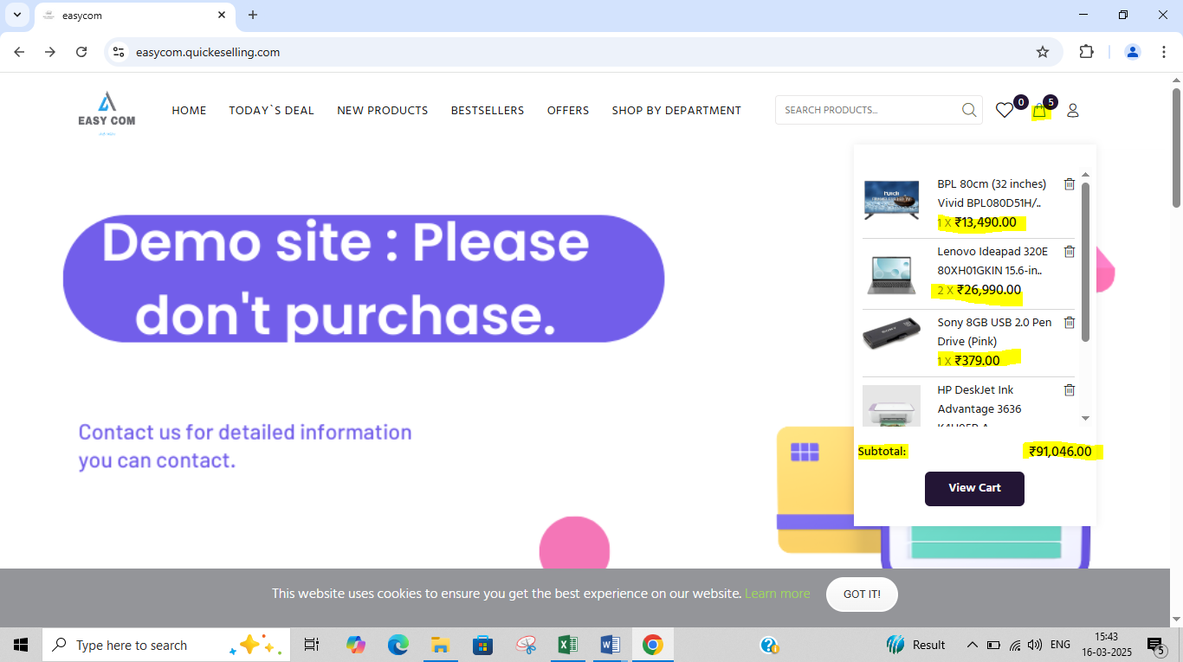

TC003_ecom_cart

Verify Items Remove from cart

open browser > enter url > system displayed home page > Select Any instock product and click on add to cart > working as expected

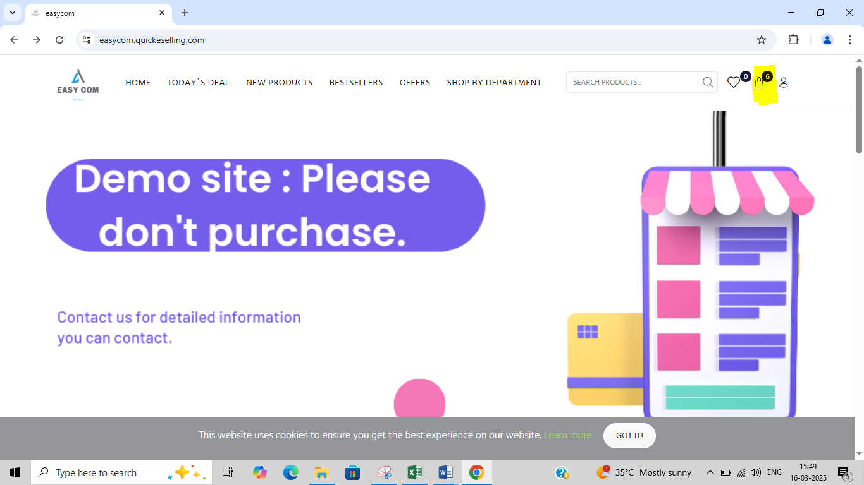

#### Click the remove button > system displayed message “Remove item or Move to Wishlist to buy later”

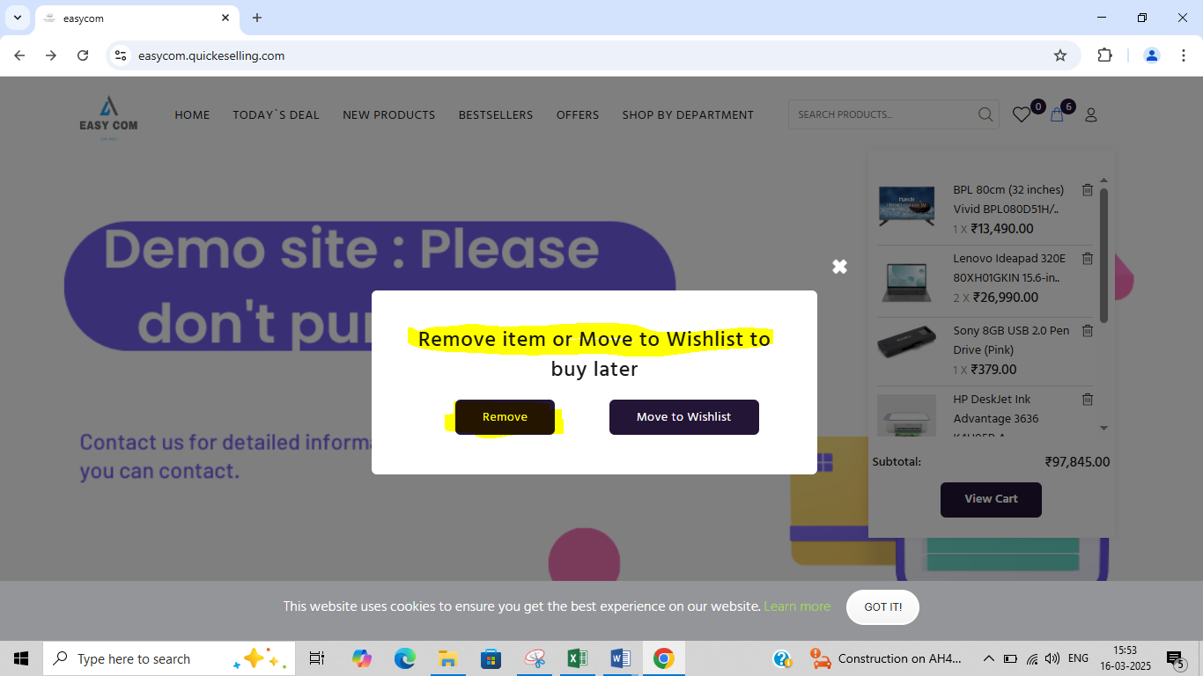

Click the remove button next to product and remove > the product removed > the cart must updated immediately.

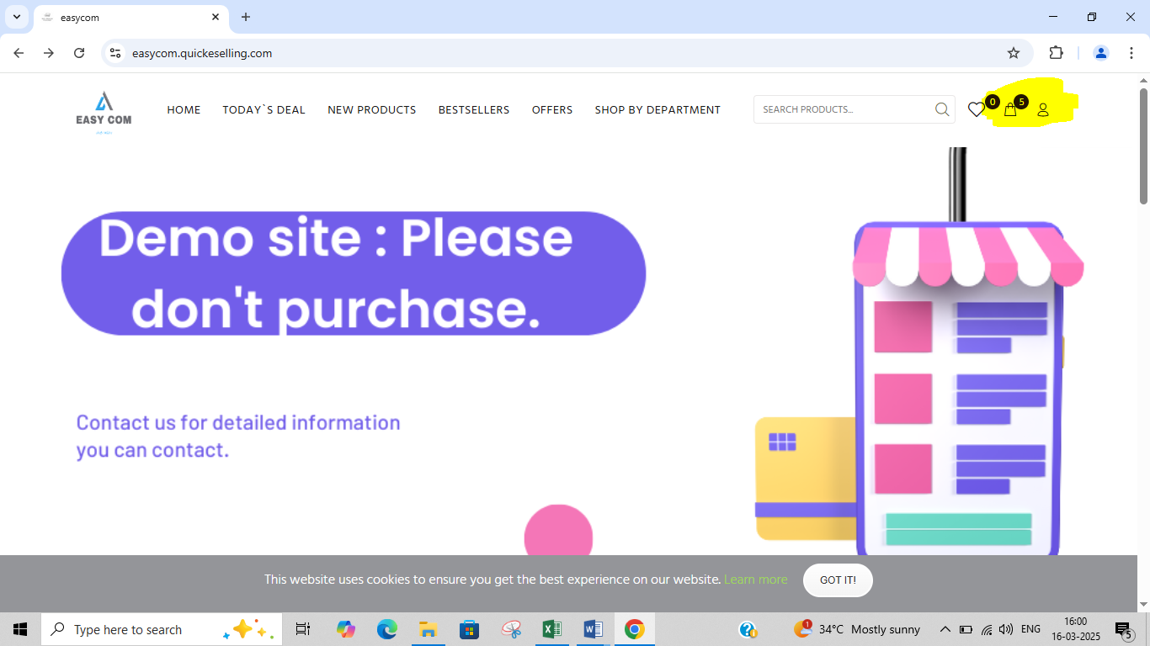

Remove all products from Cart > working as expected

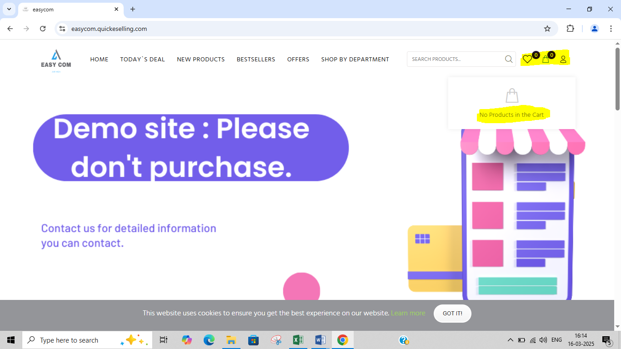

TC004_ecom_cart

Verify subtotal calculation

open browser > enter url > working as expected > Select Any instock product > click on add to cart > product added to the cart > confirmation message appeared , including product count   
verified the subtotal was the sum of all product prices

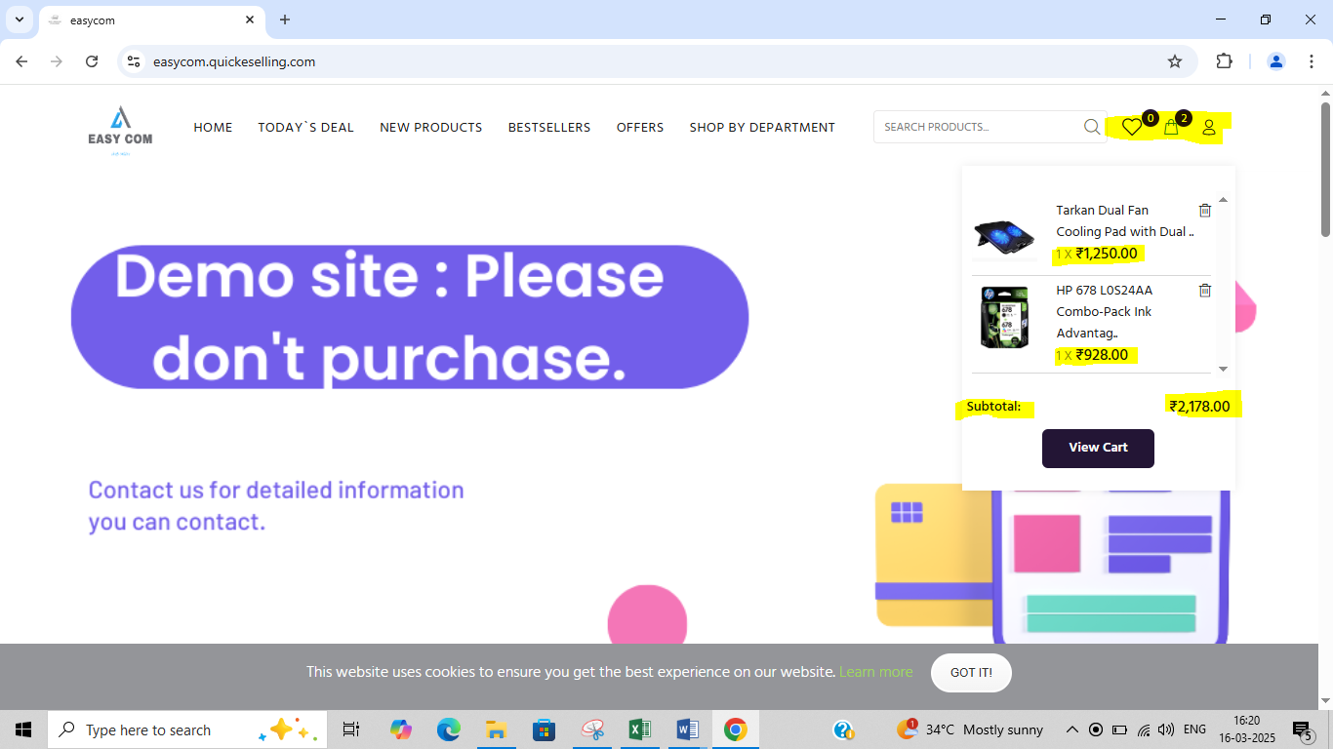

TC005_ecom_cart

Verify taxes and discount applicable and Final total

open browser > enter url > Select Any instock product > click on add to cart > The cart summary displayed the breakdown: subtotal, taxes, discounts, and final total.

